Comparison of Several Cloud Computing Platforms

From the point of deployment, cloud computing platform include three kinds, that is public cloud, private cloud and hybrid cloud. Where private cloud means the cloud infrastructure is owned or leased by only one organization, and of course management of the infrastructure is also done by the same organization. Public cloud means that the cloud infrastructure is owned by a cloud service sales organization who tries to sell cloud computing services to the public or industry circle. Hybrid cloud means that the cloud infrastructure consists of more than two kind of cloud say private cloud and public cloud in which each kind of cloud keep independent, however they are combined with some standards or special techniques and data and applications are transplant.
It is estimated that cloud computing will cause a new revolution in IT circle. Foreseeing the huge business potential, many countries, governments and corporations have made their decisions to support and invest in cloud computing related techniques. For example, US government has prepared capital in some departments for the cloud computing pilot, and the federal CIO has established cloud computing group and appointed cloud computing CTO. In UK, the digital British report published by national CIO mentioned that the government cloud G-cloud will appear soon. Early in the last year, Singapore had joined the cooperation project in cloud computing with Yahoo and Intel. India and South Korea have also put forward their cloud computing development goal. As for industry, EC2 from Amazon, Azure from Microsoft, AppEngine from Google, Blue cloud from IBM and so on are all the cloud computing platforms in use, this is a early sign that cloud computing will become the vice competition. No willing to miss the chance, many other corporations and institutes are setting their own cloud computing plans. However, as there are many the cloud platfoms, each has its own characteristics and advantages, how to make a reasonable choice is a big issue. To this problem, a detailed introduction and comparison of several popular cloud platforms is presented in this paper. From the analysis and comparison, users will be more clear to make their decisions.

1 AbiCloud cloud computing platform
AbiCloud is a cloud computing platform developed by Abiquo, a company locates in Barcelona Spain that is mainly focused on the development of cloud platform. It can be used to build, integrate and manage public as well as private cloud in the homogeneous environments. Using Abicloud, user can easily and automatically deploy and manage the server, storage system, network, virtual devices and applications and so on. The main difference between Abicloud and other cloud computing platforms is its powerful web-based management function and its core encapsulation manner. Using the Abicloud, user can finish deploying a new service by just dragging a virtual machine with mouse. This is much easier and flexible than other cloud computing platforms that deploy new services through command lines.
According to Abicloud, there is no perfect cloud platform. For each user needs his own cloud infrastructures, and every cloud provider has his own management tools, say monitor, billing and so on, so generally it is very hard to deploy a cloud platform according to user’s requirement. The best way to meet the requirement of users is to build public or private cloud with homogeneous cloud computing core and extensible infrastructures. Besides, the cloud platform should also have all kinds of interfaces that support the third parties products. With all these characteristics, providers can build the cloud computing platform of their owns.

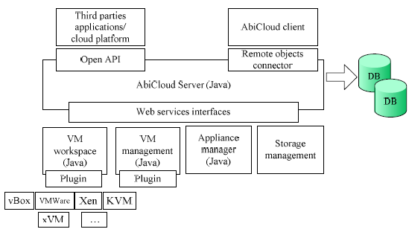
Figure 1 The structure of AbiCloud platform

Abicloud can be used to deploy and implement private cloud as well as hybrid cloud according to the cloud providers’ request and configuration. It can also manage EC2 according to the rules of protocol. Besides, apply the Abicloud, a whole cloud platform based on Abicloud can be packed and redeployed at any other Abicloud platform. This is much helpful for the transformation of the working environment and will make the cloud deployment process much easier and flexible. The architecture of Abicloud is illustrated in figure 1.
It can easily figure out that Abicloud is built based on Java, which set it irrelevant to the platform and easy to transplant. Actually, Abicloud can support many different virtual machine platforms which include vBox, VMWare, Xen, KVM and so on which make it very flexible.

2 Eucalyptus Cloud platform
Eucalyptus (Elastic Utility Computing Architecture for LinkingYour Programs To Useful Systems) project began from California University Santa Barbara, and mainly was used to build open-source private cloud platform. Now it has been run by Eucalyptus system company. Eucalyptus is an open-source implementation of Amazon EC2 and compatible with business interfaces. It also implement virtualization depending on Linux and Xen as EC2 does.
Eucalyptus is an elastic computing structure that can be used to connect the users' programms to the useful systems, it is an open-source infrastructure using clusters or workstations implementation of elastic, utility, cloud computing and a popular computing standard based on service level protocol that permit users lease network for computing capability. Currently, Eucalyptus is compatible with EC2 from Amazon, and may support more other kinds of clients with minimum modification and extension. Figure 2 demonstrates the topology structure of Eucalyptus resources.

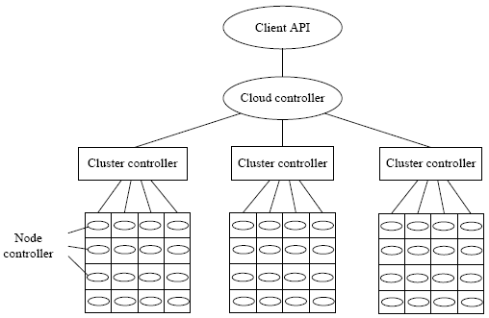
Figure 2 The resource topology structure of Eucalyptus

In figure 2, node controller is a component running on the physical resources, on which all kinds of entities of virtual machine can run. It answers for the startup, check, shutdown and clearup of the virtual machines. Logic connected node controllers form a virtual cluster, all nodes belong to the same virtual cluster report to the cluster controller and are under the control and management of the cluster controller. Virtual cluster controller runs on the head node or server of the virtual cluster, is used to access private or public network. Cloud controller is the core of the mangager of cloud platform, a component answering for global decision-making which is transplant to users. An Eucalyptus cloud has only one cloud controller. In Eucalyptus, client interface is the pass of communication and connection between the interior and the outside of Eucalyptus, through which users can access all kinds of resources on the cloud computing platform.

3 Nimbus cloud computing platform
Nimbus is an open tool set, and also a cloud computing solution providing IaaS. Put forward based on scientific research in the early stage, Nimbus have supported many nonscientific research domain applications. It permit users lease remote resources and build the required computing environment through the deployment of virtual machines. Figure 3 demonstrates the Nimbus cloud computing platform.

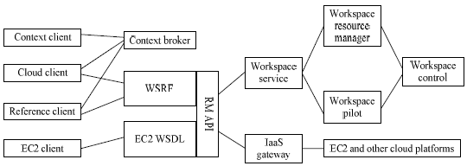
Figure 3 The structure of Nimbus cloud platform

Figure 3 shows that nimbus cloud computing platform includes many different components, say client, agent, resource manager and so on. Generally, all these functional components can be classified as three kinds. One kind is client-supported modules which are used to support all kinds of cloud clients. Context client module, cloud client module, reference client module and EC2 client module are all belong to this kind of component. The second kind of component is mainly service-supported modules of cloud platform, providing all kinds of cloud services. It includes context agent module, web service resource framework module, EC2 WSDL module and remote interface module. The third kind of component is the backgroud resource management modules which are mainly used to manage all kinds of physical resources on the cloud computing platform, including work service management module, IaaS gateway module, EC2 and other cloud platform support module, workspace pilot module, workspace resource management module and workspace controller. These components’ functions are briefed as follows:
Workspace service module is a independent virtual machine manager and can access different kinds of remote protocol. It is irrelevant to the content running on the system while relevant to the Java application. The front of web service resource framework is the protocol before applications implemented between workspace and client. The front of EC2 is an implementation of web service decription language (WSDL) fro Amzon’s elastic cloud computing platform, it permit users to develop EC2 not just nimbus cloud only. Cloud client module permit user run the requirement he want by very simple click operation. Reference client module is try to present the user all the characteristics of the front of WSRF in commandline manner. This is a bit complex as it includes scripts of some specific applications. Object pilot is a program that tries to submit tasks to the local website resource manager to obtain virtual machine manager. Usually, the pilot module is an optional choice, and the service programs just manage the nodes deployed by the pilot program instead of running it. Remote management interface is a kind of interior interface. It permit implement the remote security protocol and independently process and manage operations.
Context ageent module answer for support client and coordinate manage the auto startup serivce of the large scale clusters. Besides, it also provide personal virtual machine services and can run both on nimbus cloud platform as well as EC2 through the backend service of EC2. EC2 gateway can provide many functions, for example, running the publich Amazon virtual machine image on the Amazon cloud platform, checking the status of homogeneous wireless sensor network, notice the user the public IP of virtual machine through the characteristics of resources when it is available and so on.

4 OpenNebula cloud computing platform
OpenNebula is one of the key technologies of reservoir plan and the flagship research project in virtualization infrastructure and cloud computing of European Union. Like nimbus, OpenNebula is also an open source cloud service framework. It allows user deploy and manage virtual machines on physical resources and it can set user’s data centers or clusters to flexible virtual infrastructure that can automatically adapt to the change of the service load. The main difference of OpenNebula and nimbus is that nimbus implements remote interface based on EC2 or WSRF through which user can process all security related issues, while OpenNebula does not.

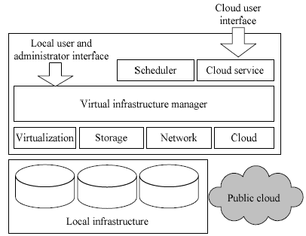
Figure 4 The structure of OpenNebula cloud platform

OpenNebula is also an open and flexible virtual infrastructure management tool, which can use to synchronize the storage, network and virtual techniques, and let users dynamically deploy services on the distributed infrastructure according to the allocation strategies at data center and remote cloud reources. Through the interior interfaces and OpenNebula data center environment, users can easily deploy any types of clouds. OpenNebula is mainly used to manage the data center of private cloud and infrastructure of cluster, and it also support hybrid cloud to connect the local and public infrastructure. This is very useful to build high scalable cloud computing environment. Besides, OpenNebula also supports public cloud platform by providing interfaces and functions to virtual machines, storage and network management and so on. Through the control interfaces, users can access services provided by OpenNebula cloud computing platform. The structure of OpenNebula is illustrated in figure 4.
OpenNebula cloud computing platform has many advantages. Firstly, from the point of infrastructure management, it can dynamically adjust the scale of the infrastructure of the cloud platform by increasing the number of hosts and partition clusters to meet different requirements. Secondly, it can centralized manage all the virtually and physically distributed infrastructures and can create infrastructure with the heterogeneous resources at data ceneter. This can guarantee use the resources more efficiently and can much reduce the number of the physical resources through the close integration of servers which further reduce the cost caused by space-saving, management, energy consumption, cooling and so on. What’s more, integration of the local resources as well as remote ones can get rid of the extra cost to meet the peak requirements. From the point of infrastructure users, OpenNebula is scalable and can rapid response to user’s requirements. From the point of system integrators, users can deploy any kind of cloud and integrate the visual data center products or services in the management tools say cloud providers, virtual machine managers, virtual image managers, service managers, management tools and so on. As OpenNebula is an open source, flexible cloud with extensible interfaces, structure and components. This makes it suit be used in any kinds of data center.
Compared with Eucalyptus, OpenNebula is more strength in the support of private cloud platform and dynamic management of the scalability of the virtual machines on clusters. To hybrid cloud, it provide on-demand access and elastic mechanisms as Amazon EC2 does.

5 Comparison of cloud platforms
Currently, there are kinds of cloud computing platforms, each has its own characteristics and advantages. To better understand these platforms, we analyze in detail and give a comparison from different implementation aspects. The characteristics and implementation of these platforms are summarized as table 1 shows. From table 1, it can figure out that though the implementation of these cloud platforms are quite different, there are much common between them. For example, they are all scalable, all provide IaaS, all support dynamic deployment of the platform, all support Xen virtualization technology, and all support linux operation system and the development of application with Java. However, there are also many differences, say their network interfaces, structure and reliability and so on. Generally, each cloud platform has its own advantages over others. For example, from the point of cloud platform deployment, Abicloud stands out. As this cloud platform can be deployed with mouse under graphic user interfaces compared others with commandline. This will be much simple to users and decrease the effort of the platform deployment. From the point of reliablity, OpenNebula is more mature. For it has considered rollback and fault tolerance mechanisms in the cloud implementation while others do not.

Table 1 The comparison of Several cloud computing platforms
